**Payoneer Customer Care Chatbot**

* **ChatBot WordPress Link:** <https://muhammaddaniyal.intelaedu.com/>
* **ChatBot Direct Preview Link:** [https://bit.ly/2ZNBBBd](https://bit.ly/2ZNBBBd?fbclid=IwAR3zJf3lW6PfZufHC293_fU-UTdIZ5JIycaCzpFQGAPiMz5cEc1ROETaYz4)
* **Certificate Link:** <https://bit.ly/2X6ZnLB>

**Questions To Ask From Jarvis The Customer Care ChatBot:**

1. I want to ask about my account balance

Can you tell me about my account balance?

1. 50266698
2. Can you provide me puchase details of my account?
3. Thakyou
4. No

----------------------------------------------------

1. Whats your name?
2. Are you human?
3. Who created you?

-----------------------------------------------------

1. Can you tell me where is your nearest customer care branch?
2. Its Opening Timing and Days?

----------------------------------------------------

1. What is Payoneer?
2. How Can i signup for payoneer?
3. What things i need to verify my payoneer?
4. How to withdraw money from payoneer?
5. How much can I withdraw from Payoneer?
6. How can I withdraw money from payoneer in Pakistan?
7. Can I transfer money from my bank account to Payoneer?
8. Can I send money from Payoneer to Paypal?
9. How long does Payoneer payment approval take?
10. Is Payoneer MasterCard is a credit card?
11. Is payoneer better than Paypal?
12. Is payoneer safe?
13. What is paypal?

Others….

**WORDPRESS**

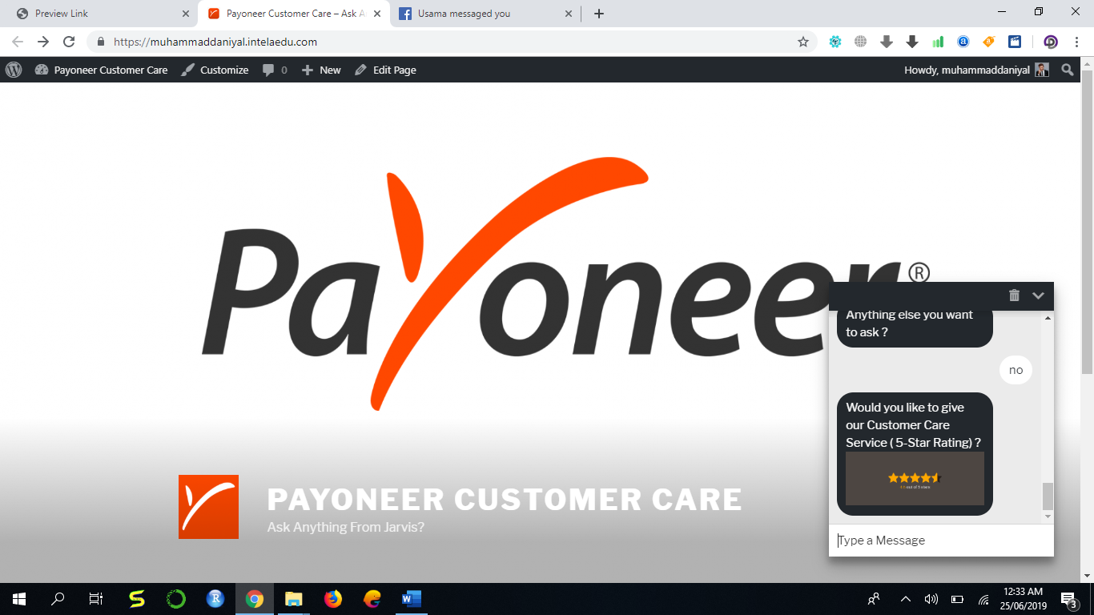

**DIRECT LINK** 